Absolute Value and Quadratics Test – Part 1

Write the letter of the choice that best completes the statement or answers the question on your answer sheet. (3 points each)

1. The vertex of the quadratic function shown in the coordinate grid is (2, 1).
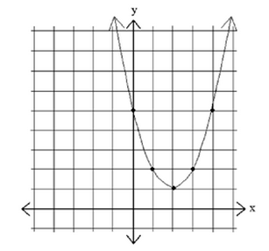

If this graph is translated 3 units up, which choice best describes the range of the translated graph?

- all numbers greater than or equal to –2
- all numbers greater than or equal to 4
- all numbers less than or equal to –2
- all real numbers

2. A function is graphed on the coordinate grid.
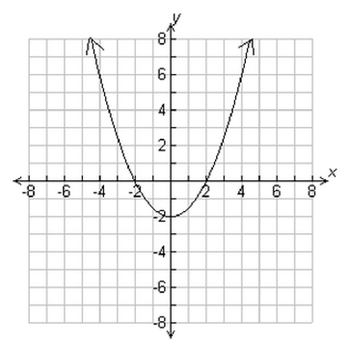

Which statement about the function represented in the graph is true?

- The function is linear.
- The function is quadratic.
- The value of the function at x = 0 is 2.
- The value of the function at x = 6 is 4.

3. The data in the table can be modeled by a quadratic function.
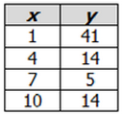

Which equation matches the function in the table?

- $f\left(x\right)=x^{2}-14x-54$
- $f\left(x\right)=-0.006x^{2}+0.12x+6.57$
- $f\left(x\right)=x^{2}-14x+54$
- $f\left(x\right)=0.006x^{2}+0.12x-6.57$

4. Examine the graph of the function.
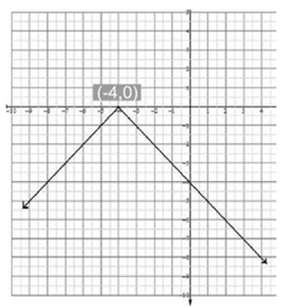

Which equation represents the graph of the absolute value function in the coordinate grid?

- $y=-\left|x-4\right|$
- $y=\left|-x+4\right|$
- $y=\left|x-4\right|$
- $y=-\left|x+4\right|$

5. Look at the graph.
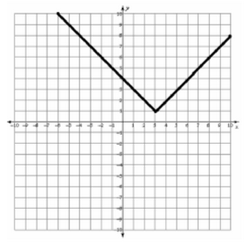

Which absolute value function is graphed?

- $f\left(x\right)=\left|x+3\right|+1$
- $f\left(x\right)=\left|x-3\right|+1$
- $f\left(x\right)=\left|x+3\right|-1$
- $f\left(x\right)=\left|x-3\right|-1$

6. The graph of a quadratic equation is in the shape of a U. Lisa was given these four equations and asked to choose the quadratic one(s).

I. $y=x^{2}-5$
II. $3x+2y=6$
III. $y=(x-2)(x+4)$
IV. $y=\left|x\right|-4$

Which one(s) should Lisa choose?

- I
- I and III
- II and IV
- IV

7. Which statement describes the graph of $f\left(x\right)=x^{2}-6x+9$?

- a line with an x-intercept of (3,0)
- a line with an x-intercept of (–3, 0)
- a parabola with an x-intercept of (3, 0)
- a parabola with an x-intercept of (–3, 0)

8. Which is the graph of $y<\left|x-1\right|-5$?
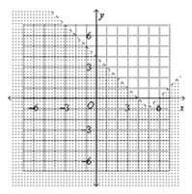
A.

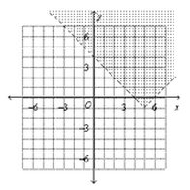

B.

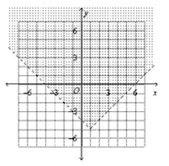

C.

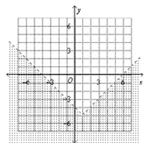

D.

9. Which choice best represents the graph of the function $y=\left|x+3\right|$?

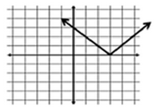
A.

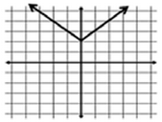
B.

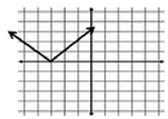

C.

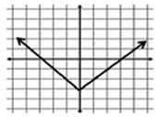
D.

10. If the graph of the equation y = x is translated up 6 units, what is the equation of the new line?

- $x=-6$
- $x=6y$
- $y=x+6$
- $y=x-6$
11. Which shows the graph of the equation $y=\left|2x-3\right|-4$?
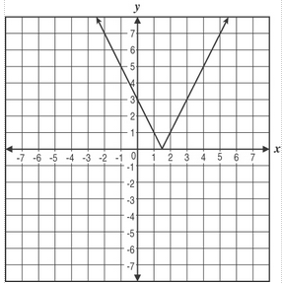

A.

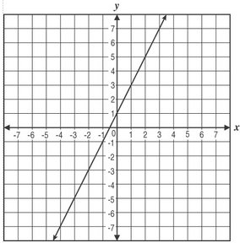

B.

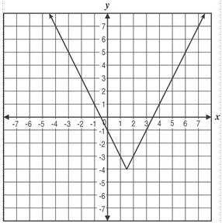
C.

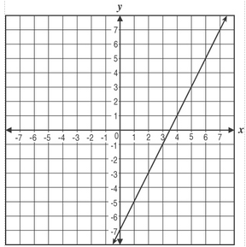
D.

12. Which graph below represents the equation $y=x^{2}+6x+5$?
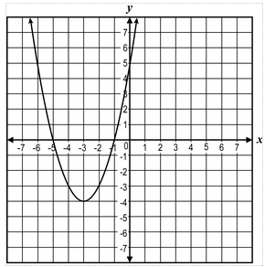
A.

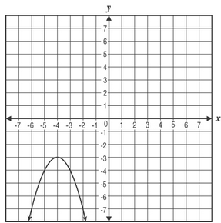

B.

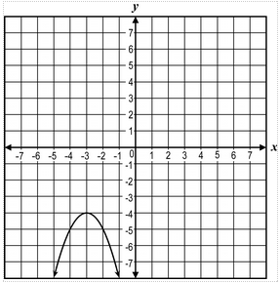

C.

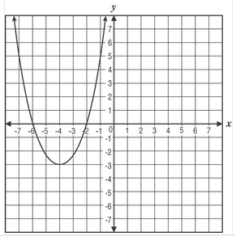

D.

13. The graph of which quadratic function opens downward at vertex (2, 5)?

- $f\left(x\right)=-x^{2}-4x+1$
- $f\left(x\right)=-x^{2}+4x+1$
- $f\left(x\right)=x^{2}-4x+9$
- $f\left(x\right)=x^{2}+4x+9$

14. The table shows selected ordered pairs for a particular function, f(x).

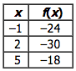

The values shown in the table correspond to which function?

- $f\left(x\right)=x^{2}-4x-29$
- $f\left(x\right)=x^{2}-3x-28$
- $f\left(x\right)=x^{2}+x-48$
- $f\left(x\right)=x^{2}+2x-38$

15. Which quadratic function f(x) is best represented by this graph?
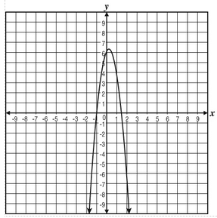

- $f\left(x\right)=-4\left(x-1\right)\left(2x+3\right)$
- $f\left(x\right)=-3(x+1)(3x-2)$
- $f\left(x\right)=-2(x+1)(2x-3)$
- $f\left(x\right)=-6(x-1)(2x-3)$

16. Study this graph of a function.

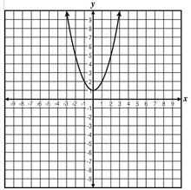

Which of these equations represents the function?

- $f\left(x\right)=x^{2}$
- $f\left(x\right)=x^{2}+1$
- $f\left(x\right)=x^{3}$
- $f\left(x\right)=x^{3}+1$

17. Which symbolic rule represents the graph of the function shown?

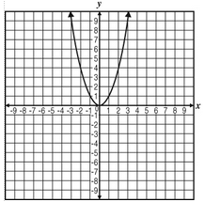

- $y=x$
- $y=\left|x\right|$
- $y=x^{2}$
- $y=x^{3}$

18. Which of these is a graph of an equation with zeros of –1 and 3 and a minimum of –4?
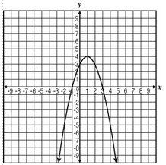
A.

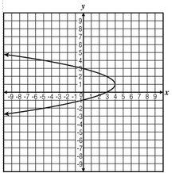
B.

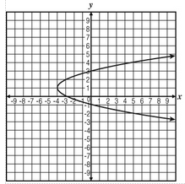

C.

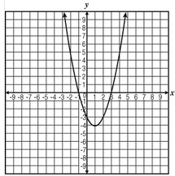

D.

For numbers 19 and 20 use the graph below.

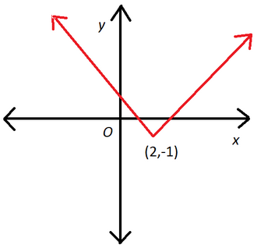

19. Which of the following best represents the domain of the given graph?

- all real numbers
- all numbers greater than or equal to 2
- all numbers less than or equal to 2
- all number greater than or equal to –1

20. Which of the following best represents the range of the given graph?

- all real numbers
- all numbers greater than or equal to 2
- all numbers less than or equal to 2
- all number greater than or equal to –1

21. If 2 is added to $x^{2}$ in the equation $y=x^{2}$ how is the graph of the parabola affected?

- shifts up 2
- shifts left 2
- shifts right 2
- shifts down 2

22. What are the zeros of the equation
$y=x^{2}-8x+16$?

- $\{0, 16\}$
- $\{-4, 4\}$
- $\{4\}$
- $\{4, 16\}$

23. Which equation represents the relationship between x and y in the table?
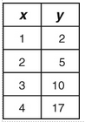

- $y=x+1$
- $y=2x+1$
- $y=x^{2}+1$
- $y={(x+1)}^{2}-2$

24. If the graph below is translated 3 units up, which equation would the graph represent?
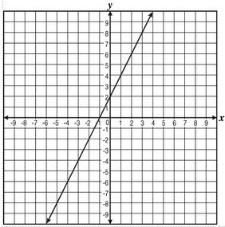

- $y=2x+2$ C. $y=2x+4$
- $y=2x+5$ D. $y=3x+5$

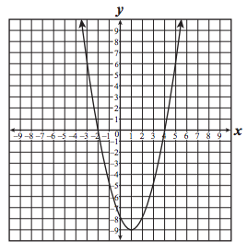
25. The graph of a quadratic function is shown below.

Which appears to be the solution set for this function?

A. $\left\{2, 4\right\}$ C. $\{-2, 4\}$
B. $\{-4, 2\}$ D. $\{-4, -2\}$

